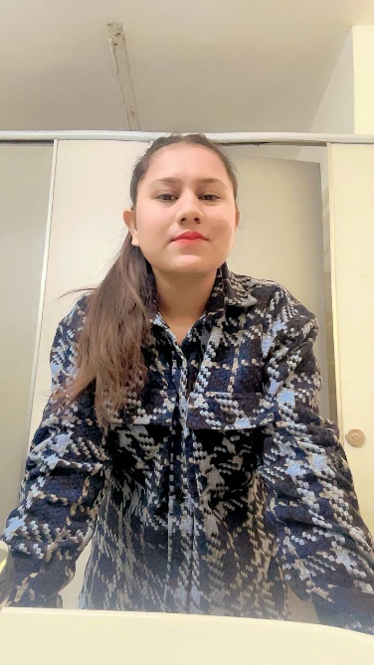

**About Me**

A passionate tech explorer driven to solve complex challenges through creativity and technology. With a robust foundation in Information Technology and *expertise* in Full-Stack Development, Business Analysis, and Microsoft PowerApps, I create innovative solutions that simplify workflows and deliver results. Fueled by curiosity and collaboration, I thrive in environments where growth meets innovation.

EDUCATION

Master’s in Information Technology

College, University

[GNDU]

2024

Bachelors in Computer Application

College, University

[GNDU]

2022

20XX

Technical Skills

* Coding
* Debugging
* Microsoft Office
* Photoshop
* UX Design
* React

Professional Development

Microsoft PowerApps

AOSC, Amritsar

2024

Business Analysis

LinkedIn,

2024

Full Stack Development

Antier Solution

Chandigarh, Mohali

Current

PHONE:8544828734

EMAIL: aryamansi033@gmail.com

ADDRESS: Chandigarh, Mohali

Mansi Tamana

[LinkedIn](https://www.linkedin.com/in/mansi-tamana-dev-life/) /[github](https://github.com/MansiAngurana/)

## Tech Stack a t a Glance

Front-End:HTML,CSS,JavaScript,React.  
 Automation-Tools:PowerApps,PowerAutomate.  
 Analysis : Business Process Mapping, Requirement Gathering.

## Key Achievements

Awarded Best Project Developer (2024) : Recognized for innovative use of PowerApps to improve organizational workflows.

Certified Problem Solver: Earned a Microsoft certification for demonstrating creative tech solutions.

**Certifications & Professional Growth**

- Microsoft Power Platform App Maker Certification**

- Full-Stack Web Development Bootcamp** – [ASB ACADEMY]

- Introduction to Data Analysis** – [LINKEDIN]

**Languages**

English | Hindi | Punjabi

**Soft Skills**

* Time Management
* Team Collaboration
* Adaptability
* Presentation Skills